Fundamentals of Data Structures
Laboratory Project 3

Project 3: Hashing
Group: 12
( Lin Weixiang , Jin Gan , Zhao Bingqian)
Date:2010-10-26

Catalogue
Hashing .................................................................................................................... 2
Chapter 1: Introduction .................................................................................................................. 4
1.1 General problem: hashing......................................................................................... 4
1.2 Problem description.................................................................................................. 4
1.3 Algorithm:Toplogical sort...........................................................................................5
Chapter 2: Algorithm Specification ................................................................................................ 6
2.1 Data structure: hashing queue ................................................................................. 6
2.2 Algorithm .................................................................................................................. 6
Chapter 3: Testing Results .............................................................................................................. 8 Chapter 4: Analysis and Comments .................................................................................................9
Appendix: Source Code (in C) ..................................................................................................10

Duty Assignments: ................................................................................................................15

Chapter 1: Introduction

General problem: hashing
So far,in the implementation of data structure operations, it seems that to perform find in a set of N elements,we have to take O(NlogN) to either sort the elements or to build a binary search tree first,and then take an average time of O(log N) to find performing insertions,deletions,and finds in constant average time.But here comes the hashing,which is more convinient but only supports a subset of the operations allowed by binary search trees.

Specific problem: Hashing
Given a hash table of size N, we can define a hash function H(x) = x%N. Suppose that the linear probing is used to solve collisions, we can easily obtain the status of the hash table with a given sequence of input numbers. However, now you are asked to solve the reversed problem: reconstruct the input sequence from the given status of the hash table. Whenever there are multiple choices, the smallest number is always taken.

Requirements: input

Your program must read test cases from the standard input.
Input consists of several test cases. For each test case, the first line contains a positive integer N (1000), which is the size of the hash table. The next line contains N integers, separated by a space. A negative integer represents an empty cell in the hash table. It is guaranteed that all the non-negative integers are distinct in the table. The input ends with N being 0. That case must NOT be processed.

Requirements: output
For each test case, output to the standard output. Print a line that contains the input sequence, with the numbers separated by a space. Notice that there must be no extra space at the end of each line. What’s more, the running time is limited to 1 second.

Algorithm: Toplogical sort Queue
According to Theorem 9.2, we here use a Toplogical sort to compare and store the cost of all the possibilities of the input sequence.Then we use a queue to store the toplogical sequence,and do a toplogical sort ,do the enqueue and dequeue operation to insert the elements in the queue to the output in a increasing sequence.Until the queue comes empty.

Chapter 2: Algorithm Specification

Data structure: hashing queue
Casue the problem is about hashing ,the hashing struture is quite normal to be involved.And in our program,we use a queue structure to store the elements we used.

Algorithm: Topological sort
#include<stdio.h>
#define maxn 1000

typedef struct Node *List;
struct Node{
int d;
List next;
};

typedef int Data[maxn];
typedef List AdjList[maxn];

void work(int);
void insert(List,int,Data);
List NewNode(void);
void ErrOut(char *);

int main(void){
int n;
for(scanf("%d",&n);n;scanf("%d",&n)) work(n);
}
int Num,i,j,k,x;
Data d,r;
AdjList m;

Num=0;
for(i=0;i<n;i++){
scanf("%d",&d[i]);
if(d[i]>=0)Num++;
r[i]=0;
m[i]=NewNode();
m[i]->next=NULL;
}
h=NewNode();
h->next=NULL;

for(i=0;i<n;i++)
if(d[i]>=0){
x=d[i]%n;
r[i]=i-x;
if(r[i]<0)r[i]+=n;
if(r[i])
for(j=x;j!=i;){
p=NewNode();
p->d=i;
p->next=m[j]->next;
m[j]->next=p;
j++;
if(j==n)j=0;
}
else
insert(h,i,d);
}
while(h->next){
p=h->next;
h->next=p->next;
k=p->d;
free(p);
Num--;
if(Num)
printf("%d ",d[k]);
else
printf("%d\n",d[k]);
for(p=m[k]->next;p;p=p->next)
if(--r[p->d]==0)insert(h,p->d,d);
}
}

void insert(List h,int i,Data d){
int key;
List p,q;

p=NewNode();
p->d=i;
key=d[i];

for(q=h;q->next&&d[q->next->d]<key;q=q->next);
p->next=q->next;
q->next=p;
}

List NewNode(void){
List p;
p=NULL;
p=malloc(sizeof(struct Node));
if(!p)ErrOut("Out of space!");
return p;
}
void ErrOut(char *str){
puts(str);
exit(1);
}

Chapter 3: Testing Results
We run a case “repeat” times to compute run time which is shown in the table below. And the average time is the real run time for each case.
Figure 3.1 Testing Results
Case | Input description |  |  |  | result
Case | N | Hash table | Repeat | comments | Run time  (second) | Output | Comment
1 | 0 |  |  | Quit case |  | Quit | Pass
2 | 3 | “3 1 2” | 100000 | Sample | 0.346000 | correct | Pass
3 | 11 | “33 1 ……-1 21” | 100000 | Sample | 1.936000 | correct | Pass
4 | 100 | See the input.txt | 10000 |  | 3.189000 | correct | Pass
5 | 500 | See the input.txt | 1000 |  | 5.939000 | correct | Pass
6 | 800 | See the input.txt | 100 |  | 1.589000 | correct | Pass
7 | 1000 | See the input.txt | 100 |  | 2.498000 | correct | Pass
8 | 1000 | “0 1 2 3 …… 999” | 1000 | Best case | 3.663000 | correct | Pass
9 | 1000 | Hash [ i ] = i*1000 | 10 | Worst case | 3.228000 | correct | Pass

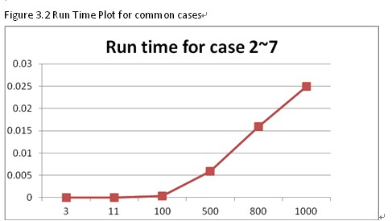
Figure 3.2 Run Time Plot for N=1000 cases
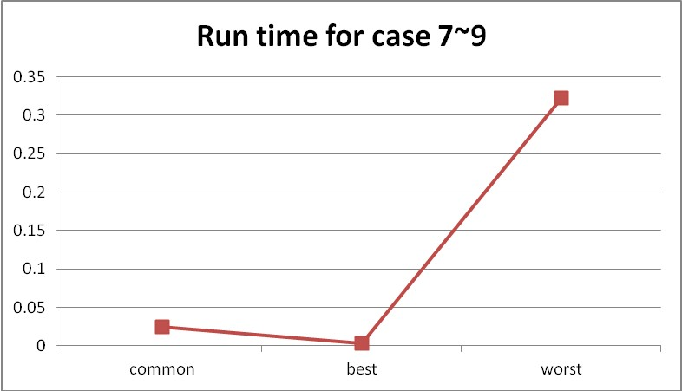
Chapter 4: Analysis and Comments

Time Complexity Analysis
Time complexity is indeterminate. It depends on the number of the collisions.
1. The best case for this algorithm O(N), as there is no collision.
2. The worst case for the algorithm is O(N²), which is in the situation that all item hashed aim to same position, and the collision is O(N²).
3. In other cases, it is absolutely between O(N) and O(N²).

Space Complexity Analysis
This algorithm first allocates 1000 base space, and then adds items as long as the collision occurs.
Considering the worst case, the space cost is up to 1000 + O(N²), which n is the number of item.

Comments
- The 1000 base space should be allocated dynamic.
- As there is so many item inserting or deleting, so we may use small object manager to save base.
- There are some little problems in the main function. The input code seems hard to read and not good for the maintenance and modification.
The input and output code should be split from the computing code, for easy time testing, which also makes the code more clear. Better if the algorithm is designed off-line.

Appendix: Source Code (in C)
Filename: cy_G12_P3.c
Coder: Zhao Bingqian
Date: 2010/10/26
/*
* cy_G12_P3.c - the program for Project 3 of Fundamentals of Data Structures.
* Copyright (C) Zhao Bingqian of Group 12. All rights reserved.
* Purpose: reconstruct the input sequence from the given status of the hash table.
* Instructor: Chenyue.
* Version: 2010/10/26
*/

#include<stdio.h>

/*
*member 'position' is used to store the original position of this element in the hash table
*define the max data number.
*/
#define maxn 1000

/*
*define the struct of link list which is used in adjacency list struct and queue struct.
*member 'd' is used to store the data of the node.
*member 'next' is used to point the next node.
*/
typedef struct Node *List;
struct Node{
int d;
List next;
};

/*
*define the n-sized array to store the input data and the in-degree of each vertex.
*/
typedef int Data[maxn];

/*
*define the adjacency list to store the topological order of each input data.
*/
typedef List AdjList[maxn];

void work(int);
void insert(List,int,Data);
List NewNode(void);
void ErrOut(char *);

int main(void){
int n;
/*handle each n-sized data by calling function work(), until n equals 0.*/
for(scanf("%d",&n);n;scanf("%d",&n)) work(n);
}

/*handle the case which has n input data.*/
void work(int n){
/*
*variable 'Num' is the number of the nonnegative data.
*variable 'x' is the remainder of a data mod n.
*/
int Num,i,j,k,x;
/*
*array 'd' is used to store the input data.
*array 'r' is used to store the in-degree of each vertex.
*/
Data d,r;
/*adjacency list m is used to store the topological relation of each input data.*/
AdjList m;
/*queue 'h' is used to store the vertexs with 0 in-degree.*/
List h,p;

/*
*read in the n data, count the nonnegative data number, creat an empty adjacency list.
*/
Num=0;
for(i=0;i<n;i++){
scanf("%d",&d[i]);
if(d[i]>=0)Num++;
r[i]=0;
m[i]=NewNode();
m[i]->next=NULL;
}

/*
*build up the adjacency list according to the input order
*initialize the queue which stores the vertexs with 0 in-degree.
*/
h=NewNode();
h->next=NULL;

for(i=0;i<n;i++)
if(d[i]>=0){
/*count the collisions of data[i] which equals to its in-degree r[i].*/
x=d[i]%n;
r[i]=i-x;
if(r[i]<0)r[i]+=n;
/*if there are collisions of data[i], add them into the adjacency list.*/
if(r[i])
for(j=x;j!=i;){
/*for each collision, add into the adjacency list.*/
p=NewNode();
p->d=i;
p->next=m[j]->next;
m[j]->next=p;
/*count the next collision.*/
j++;
if(j==n)j=0;
}
/*if there is no collision of data[i], add it into the queue.*/
else
insert(h,i,d);
}

/*
*topological sort the data according the adjacency list using the queue.
*/
while(h->next){
/*dequeue the first item, copy the data, free the space.*/
p=h->next;
h->next=p->next;
k=p->d;
free(p);

/*
*print out the input sequence separated by a space,
*and no extra space at the end of the line.
*/
Num--;
if(Num)
printf("%d ",d[k]);
else
printf("%d\n",d[k]);

/*
*decrease the in-degree of adjacency nodes,
*add the new 0-in-degree node into the queue.
*/
for(p=m[k]->next;p;p=p->next)
if(--r[p->d]==0)insert(h,p->d,d);
}
}

/*
*insert the new item into the queue in increasing order according to its data.
*/
void insert(List h,int i,Data d){
int key;
List p,q;

/*create a new node 'p' to store the item.*/
p=NewNode();
p->d=i;
key=d[i];

/*search for right position in the queue of the item to insert in from the head.*/
for(q=h;q->next&&d[q->next->d]<key;q=q->next);
p->next=q->next;
q->next=p;
}

/*apply for a new link list node.*/
List NewNode(void){
List p;
p=NULL;
p=malloc(sizeof(struct Node));
if(!p)ErrOut("Out of space!");
return p;
}

/*print out the error information and quit.*/
void ErrOut(char *str){
puts(str);
exit(1);
}

Declaration
We hereby declare that all the work done in this project titled " Hashing" is of our independent effort as a group.

Duty Assignments:
Programmer: Zhao Bingqian
Tester: Lin Weixiang
Report Writer: Jin Gan

